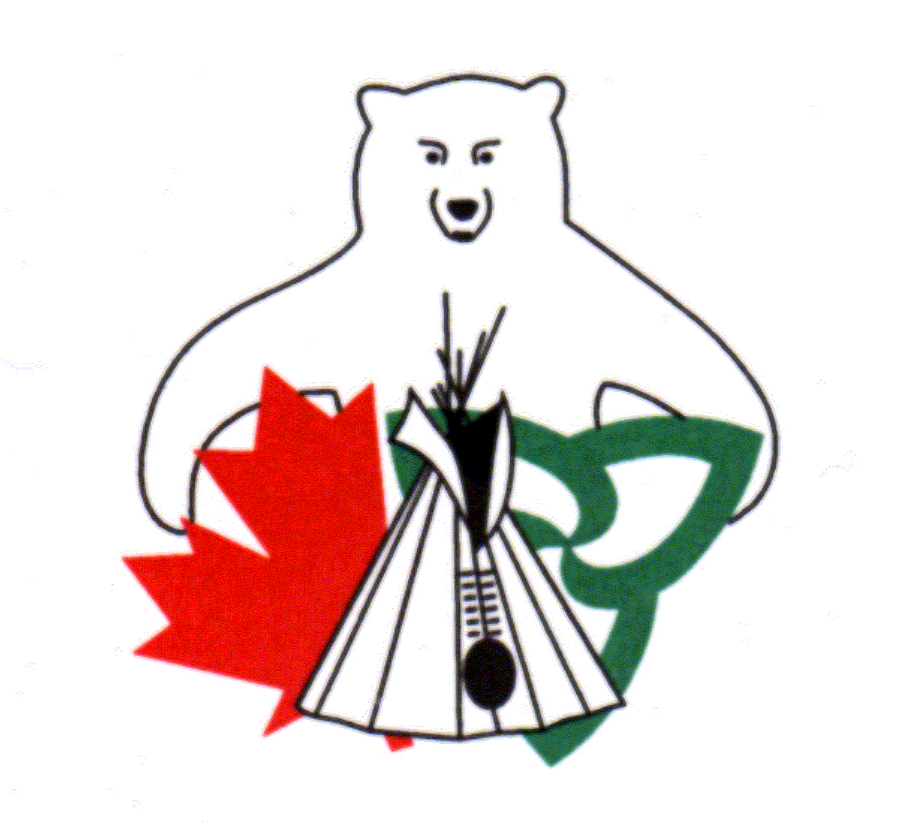
Do you have a natural resource management or conservation project in mind for your community or know of members planning to undertake work in this area?

The Canada Ontario Resource Development Agreement (CORDA) Office is now accepting applications for 2016-2017

The Canada Ontario Resource Development Agreement (CORDA) is an agreement between Canada, Ontario and First Nations’ members in Ontario. CORDA is funded by Aboriginal Affairs and Northern Development Canada and the Ontario Ministry of Natural Resources. The Agreement promotes resource and economic development initiatives of First Nations’ members by providing financial assistance to develop and utilize renewable natural resources.

First Nations, their members and organizations, and Treaty organizations in Ontario are eligible to apply for funding. The maximum funding level for projects is $35,000.00 per year.

Eligible applications must involve one or more of the following:

- Commercial Fishing, including all aspects of sustained yield production and quality control
- Fur Trapping, including all aspects of trap line management and pelt quality control
- Forestry, harvesting, maintenance, renewal and access
- Non-timber forest products including wild rice, blueberries, wild traditional crops and medicinal plants
- Deer, bear, barren-ground caribou and moose hide utilization
- Sports fishing and hunting, including assistance to guides and outfitters
- Fishing and hunting for domestic use
- Commercial recreation related to the development of renewable natural resources including ecotourism, hunting camps, guiding, skiing and snowmobile trails
- Processing and marketing of products derived from natural resource development, management and harvesting
- Environmental projects relating to resource development
- Natural resource planning such as those projects related to natural heritage or addressing invasive species

Funding for 2016-2017 and beyond is subject to confirmation of funding. Proposals will be received and reviewed in anticipation of funding availability. However, please note that if funding is not approved, approval of projects will not be realized.

to request a copy of the application package, contact:
Jill Stevens
CORDA Secretariat
123 Paudash Street
Hiawatha, ON K9J 0E6
Ph: 705-295-7116
E-mail: corda@nexicom.net.

Applications must be received by the CORDA Office by Monday, October 6, 2014 at 11:59 p.m. EDT

