Jordan’s Principle

Looking for community members that may need support for the following.
- Has your child’s case been denied payment for specialized treatment services?
- Are these services available to other children outside of the community?
- Do you need support navigating the service systems?
If you require advocacy support or have concerns about a recent denial for your child’s health or social service treatments please contact your Health Centre or the Association of Iroquois Allied Indians Office.

Jordan’s Principle- Addressing in a timely manner the needs of First Nation children living on-reserve with a disability or a short-term condition.
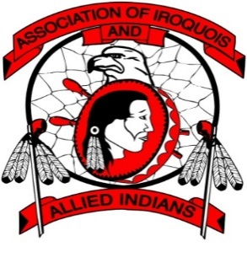 |  | Association of Iroquois and Allied Indians  387 Princess Ave.  London, Ontario  N6B 2A7  519-434-2761  | www.aiai.on.ca |

