SAVE THE DATE “climate change symposium”  When  March 6 – 7, 2018  Where  Oneida Nation Community Centre  ROOM: BEAR’S DEN  2017 Ball Park Rd., Southwold, ON N0L 2G0  Topics of Discussion:  · Securing Provincial Funding  · Alternative Energy and Housing  · Economic Development  · Adaptation and Traditional Ecological Knowledge  ASSOCIATION OF IROQUOIS AND ALLIED INDIANS  WWW.AIAI.ON.CA 519.434.2761  FOR FURTHER DETAILS CONTACT CHRIS HOYOS (CHOYOS@AIAI.ON.CA) | 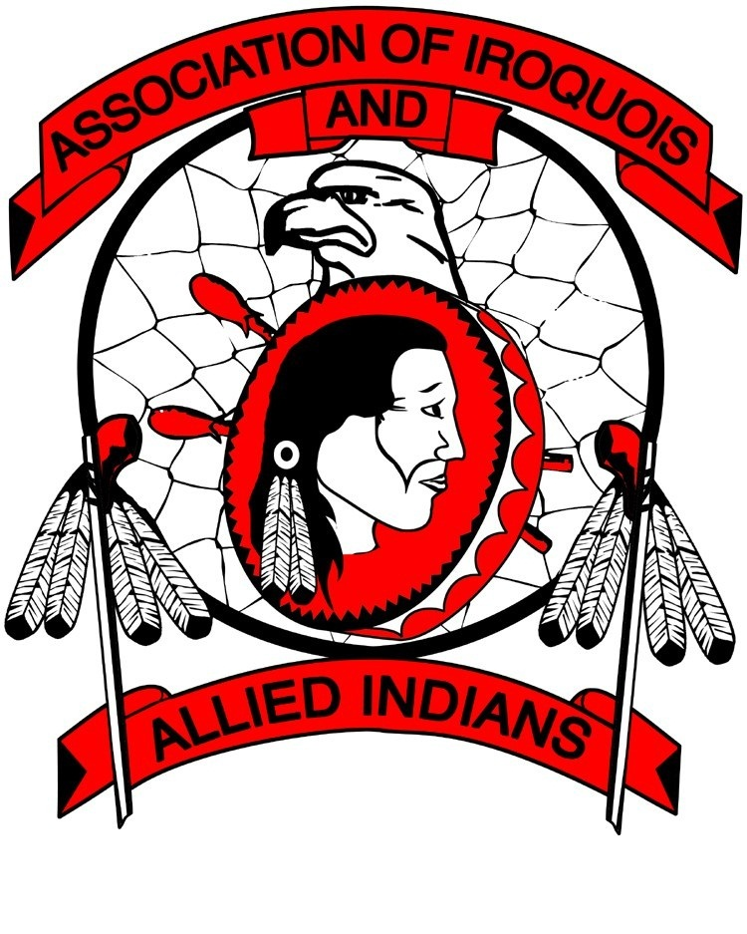  WHO SHOULD ATTEND:  First Nation Leadership  Political Portfolios  Environmental Technicians  SPONSORSHIP  AIAI will reimburse mileage and meals for three representatives per member Nation. Member Nations are welcome to send additional representatives at their own expense.  FURTHER DETAILS WILL BE COMING IN THE NEAR FUTURE.

