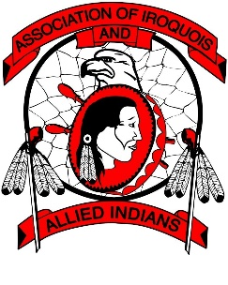
Association of Iroquois and Allied Indians
YOUTH ACCESSIBILITY FORUM
Oneida Nation of the Thames – Community Centre (Bear’s Den)
March 23 - 25, 2018

REGISTRATION FORM

CONTACT INFORMATION (PLEASE PRINT)

First Name: Last Name:

First Nation/Organization:

Address:

City/Town: Province: Postal Code:

Email Address:

Telephone: Fax:

ACCOMMODATIONS:
Accommodation arrangements will be made on your behalf at the Four Points by Sheraton, 1150 Wellington Rd. S., London, ON. All rooms will be direct billed to the Association. Please have the completed registration forms submitted to the attention of Kristin Doxtator (KDoxtator@aiai.on.ca) no later than Fri. Mar. 9th, 2018 by 4:00 p.m.

Do you require accommodations? YES NO
If yes, please check off dates required: Mar. 23rd Mar. 24th
*Note: Please notify us of any special requirements or needs, ie: dietary, accessibility, translation, etc. in advance so that we can make the appropriate considerations.
REIMBURSEMENT:
Reimbursement will be provided following the Forum for travel and any applicable meals at the AIAI rates. Snacks and lunch will be provided during the Forum so please budget accordingly.
PHOTO CONSENT:
I agree that AIAI, it’s representatives and staff, have the right to take photographs of myself during the Youth Forum 2018. I authorize AIAI to copyright, use, and publish any photographs or videos in both prints and electronic forms.
I agree that AIAI, its representatives and staff, may use the photographs for any lawful purpose, including publicity, illustration, advertising, presentations, and web content.
I have read and understood the above:

Signature Date

